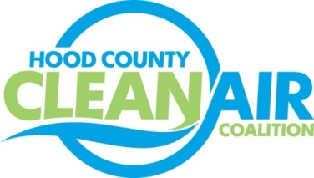
Meeting: Tuesday, June 3, 2014
Granbury Resort Conference Center, Boardrooms 1-2
621 East Pearl Street, Granbury, Texas 76048
8:30-9:30 a.m.

Agenda

- Call Meeting to Order
- Updates - Michelle McKenzie
  - Conference Call Reports
    - Ozone Advance
    - Air North Texas
  - Ozone Advance Annual Report Status
  - North Texas Commission Webinar Series Report– Bike Friendly North Texas
  - Rider 8 Status
- Discussion
- Adjourn

